Concordia University

Smart Home System simulator

Team 2

Francesco Benvenuto 40019845, section HC

Julien Fadel 40002473 section H

Ashraf Khalil

Martin Marcos 40041398, section H

Adam Richard

Derek Ruiz-Cigana 40096268, section H

T.A:

Yashika Khurana

Professessor:

Dr. Rodrigo Morales

Delivery 1 due date: October 20, 2020

Table of contents

Introduction………………………………………………………………………………………………..2

Scope…………………………………………………………………………………….........................3

Use Case Tables…………………………………………………………………………………………4

Cross-referenced Diagrams……………………………………………………………………………..7

Introduction

The smart home simulator allows you to simulate a smart home system on a 2D representation of the house. The automatic functionality of this system includes: home security, home heating system and lighting that allows you to open doors and windows. Also an easy to use user interface allows the user to interact with the simulator, with profile features and authorization. Furthermore, it allows the user to add more modules to the system easily thanks to the modular approach of coding.

Deliverable 1 scope

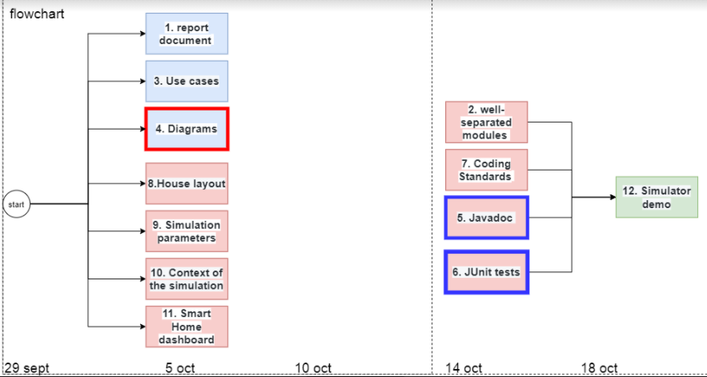

Fig1.Deliverable 1 scope flow chart

As you can see in Fig1, the scope of this project comprises: documentation, 1 formal document with uses cases and diagrams (1,2,3,4), a working user interface dashboard that users can use to interact with the simulation (turn on lights, temperature change) (8,11), the modules SHC,SHH,SHS and SHP that are the core components that makes the simulation work(9,11,2), Javadoc and Junit tests along with respecting coding standards (7,5,6) and a video demo showing the functionality of the simulator. The project should be done by 18 of October.

Use Case Tables

|  |  |
| --- | --- |
| Use case | Manage house layout files |
| Level | subfunction |
| Description | * System can read imputed house layout file from user and load it to the dashboard for to user to interact with * User can add/remove/modify profiles |
| Preconditions | User has inputted a valid layout file to the system |
| Triggering event | System reads layout file |
| Main flow | 1. System reads layout file 2. System generates correct number of rooms, doors, windows and lights. 3. System displays visible house layout to the dashboard |
| Extensions | * User is denied because of wrong authorization * System malfunctions and does not read house layout * Invalid house layout introduced * System outputs incorrect house layout |
| Postconditions | System recognizes valid layout file imputed and loads it to the dashboard for the user to interact with |

|  |  |
| --- | --- |
| Use case | Add/remove edit user profiles |
| Level | User level |
| Description | User can add/remove profiles |
| Preconditions | System is correctly installed |
| Triggering event | The user chooses the option to edit profile |
| Main flow | 1. User powers on the simulation 2. User edits user profiles 3. System receives input and updates accordingly |
| Extensions | * User is denied authorization * System malfunctions and does not output inputs accordingly * User inputs invalid settings * User is able to access system even though he does not have authorization (authorization failure) |
| Postconditions | User edits profiles and the system updates accordingly |

|  |  |
| --- | --- |
| Use case | Set date and time |
| Level | User level |
| Description | User can set date and time |
| Preconditions | System is correctly installed |
| Triggering event | The user chooses the option to set date and time |
| Main flow | 1. User powers on the simulation 2. User sets date and time 3. System receives input and updates accordingly |
| Extensions | * User is denied authorization * System malfunctions and does not output inputs accordingly * User inputs invalid settings * User is able to access system even though he does not have authorization (authorization failure) |
| Postconditions | User sets date and time and the system updates accordingly |

|  |  |
| --- | --- |
| Use case | Log in using an existing user profile and set house location |
| Level | User level |
| Description | User can Log in using an existing user profile and set house location |
| Preconditions | System is correctly installed |
| Triggering event | User selects a profile to Log in with and chooses the option to set house location |
| Main flow | 1. User powers on the simulation 2. User logs in using an existing user profile 3. User sets house location 4. System receives input and updates accordingly |
| Extensions | * User is denied authorization * System malfunctions and does not output inputs accordingly * User inputs invalid settings * User is able to access system even though he does not have authorization (authorization failure) |
| Postconditions | User logs in and sets house location and the system updates accordingly |

|  |  |
| --- | --- |
| Use case | Start/stop simulation |
| Level | User level |
| Description | User can start/stop the simulation |
| Preconditions | System is correctly installed |
| Triggering event | User selects the option to start or stop the simulation |
| Main flow | 1. User powers on the simulation 2. System receives input and updates accordingly 3. User powers off the simulation 4. System receives input and updates accordingly |
| Extensions | * User is denied authorization * System malfunctions and does not output inputs accordingly * User inputs invalid settings * User is able to access system even though he does not have authorization (authorization failure) |
| Postconditions | User turns on the simulation to simulate scenarios and turns off the simulation |

|  |  |
| --- | --- |
| Use case | Modify date and time |
| Level | User level |
| Description | User can modify date and time |
| Preconditions | System has valid parameters set up |
| Triggering event | User chooses the option to modify date and time |
| Main flow | 1. User powers on the simulation 2. User modify date and time 3. System receives input and updates accordingly |
| Extension | * User is denied authorization * System malfunctions and does not output inputs accordingly * User inputs invalid settings * User is able to access system even though he does not have authorization (authorization failure) |
| Postconditions | User modifies date and time and the system updates accordingly |

|  |  |
| --- | --- |
| Use case | Move the logged user to different room |
| Level | User level |
| Description | User can move to a different room |
| Preconditions | System had valid parameters set up |
| Triggering event | User chooses the option to move to a different room |
| Main flow | 1. User powers on the simulation 2. Move the logged user to different room 3. System receives input and updates accordingly |
| Extensions | * User is denied authorization * System malfunctions and does not output inputs accordingly * User inputs invalid settings * User is able to access system even though he does not have |
| Postconditions | User was moved to a different room, the system receives input and reacts accordingly |

|  |  |
| --- | --- |
| Use case | Place people in specific rooms |
| Level | User level |
| Description | User can place people in specific rooms |
| Preconditions | System had valid parameters set up |
| Triggering event | User chooses option to place people in specific rooms |
| Main flow | 1. User powers on the simulation 2. Move a person or people to a specific room 3. System receives input and updates accordingly |
| Extensions | * User is denied authorization * System malfunctions and does not output inputs accordingly * User inputs invalid settings * User is able to access system even though he does not have |
| Postconditions | Person or people are moved to a specific room, the system receives input and reacts accordingly |

|  |  |
| --- | --- |
| Use case | Modify temperature outside home |
| Level | User level |
| Description | The user can modify the temperature outside the home |
| Preconditions | System has valid parameters set up |
| Triggering event | User chooses option to modify temperature outside home |
| Main flow | 1. User powers on the simulation 2. Modify temperature outside home 3. System receives input and updates accordingly |
| Extensions | * User is denied authorization * System malfunctions and does not output inputs accordingly * User inputs invalid settings * User is able to access system even though he does not have |
| Postconditions | User modifies the temperature outside, the system receives input and reacts accordingly |

|  |  |
| --- | --- |
| Use case | Block windows movement by putting an arbitrary object |
| Level | User level |
| Description | User can block windows movement by placing an arbitrary object |
| Preconditions | System has valid parameters set up |
| Triggering event | User places an arbitrary object which will block window |
| Main flow | 1. User powers on the simulation 2. Block windows movement by putting an arbitrary object 3. System receives input and updates accordingly |
| Extensions | * User is denied authorization * System malfunctions and does not output inputs accordingly * User inputs invalid settings * User is able to access system even though he does not have |
| Postconditions | User blocks window by putting an arbitrary object, the system receives input and reacts accordingly |

Cross-referenced Diagrams

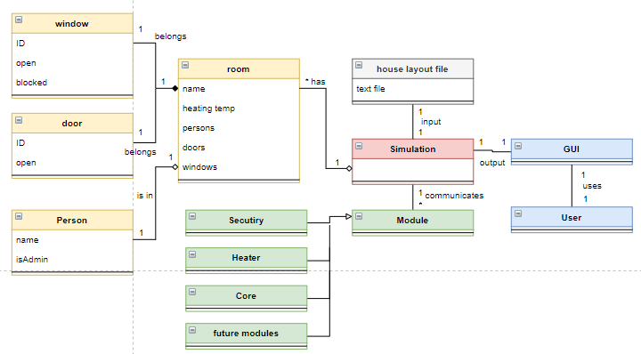

Fig2. Domain model class diagram

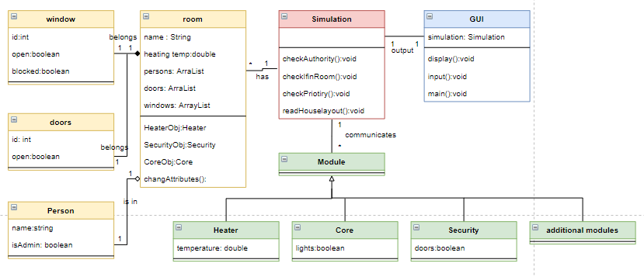

Fig3. Class diagram

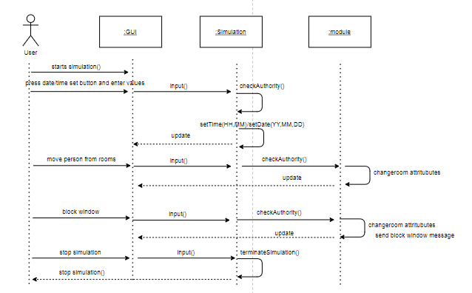

Fig4. Sequence diagram